WP3 – D3.7 Trustworthy AI: Algorithm Assessment Building Block

PROJECT
Project number: | [101123471]
Project name: | [European Dataspace for Growth and Education - Skills]
Project acronym: | [EDGE SKILLS]

REPORTING PERIOD
Please note that you must report on the entire reporting period.
RP number: | 1
Duration: | from [01/01/2024] to [31/12/2025]


European Union
The European Commission is funding the data spaces and infrastructure construction through the Digital Europe program.

TABLE OF CONTENTS
TABLE OF CONTENTS 2
1 Executive Summary 3
2 Business Value and Use Case Experience 5
2.1 Business value of the Building Block 5
2.2 Use case feedback 7
A. CARiSMA Use Case 7
B. LOLA Use Case 8
C. AffectLog Use Case 9
3 CARISMA Updated User Guide 11
3.1 Basic information 11
3.2 Short summary of functionalities 11
3.3 Demonstration of technical scenarios 11
4 LOLA Platform Updated User Guide 13
4.1 Basic information 13
4.2 Short summary of functionalities 13
4.3 Demonstration of technical scenarios 13
5 AFFECTLOG Updated User Guide 17
5.1 Basic information 17
5.2 Short summary of functionalities 17
5.3 Demonstration of technical scenarios 18
6 Summary 20
6.1 Summary of the implemented service 20
6.2 Planned Improvements 20
6.3 Extension possibilities 21
Annex A – Design document of the Building Block 22
Annex B – Technical Overview of the Building Block 70

Executive Summary
Summary
According to the European AI Act, it is essential to analyze risks and comply with the obligations associated with the identified risk levels. Trustworthy AI Assessment Building Block offers a variety of tools and methods adaptable to different situations to help auditors establish an objective risk analysis for solutions offered by EdTechs. The features provided by the Trustworthy AI BB tools also refer to the risks identified by the Open Web Application Security Project (OWASP) in the field of AI.
The Building Block is designed as a toolbox composed of three tools, respectively named LOLA, CARISMA, and Affectlog, each designed as measuring instruments for AI systems used at different stages of system design and development. One way to highlight the complementarity of CARiSMA, AffectLog, and LOLA is to present them from the perspective of the lifecycle of the applications to be evaluated (see Figure 1).
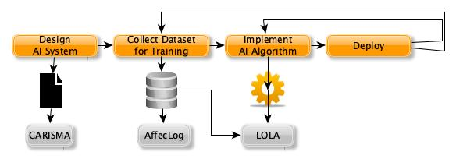
Figure 1. AI System life cycle
CARiSMA makes it possible to identify vulnerabilities from the design stage of systems. For this, it uses models of developed systems such as AI-enabled systems. CARiSMA already supports checks for security threats and for non-fulfillment of modeled requirements, and during the project, is extended to particularly check for AI-specific threats, e.g., those threats as identified and cataloged by the OWASP project and published as the OWASP Machine Learning Security Top 10.
LOLA, for its part, aims to measure quality indicators specific to application domains. It allows for the assessment of the quality and accuracy of the algorithms. tested in a context as close as possible to the real world, using the same dataset as that used by a targeted application or service. This is achieved thanks to a workflow that preserves the security and confidentiality of the data sent to the platform.
AffectLog applies at operation time, where an AI model and/or data pipeline already exists, and supports trustworthiness assessment through dataset–model interface profiling (e.g., identifiers, sparsity, drift), simple concentration/fairness indicators, and audit-oriented documentation outputs (e.g., SOPs and structured metadata).

Main business value of the building block
CARISMA | - Better estimation of potential vulnerabilities  - Identification of OWASP identified ML Security threats | - Compliance with AI Act (Risk analysis)  - AI ethics support in the entire lifecycle
LOLA | - Accurate evaluation of algorithms to reduce risks  - Transparency (Trust)
AffectLog | - Risk and quality assessment of datasets and models, especially in sensitive contexts  - Granular bias metrics beyond performance metrics for increased trust in the governance.

Status and use case feedback
For CARISMA, the University of Koblenz focused its work on the feasibility of extending the AI ​​systems specification to address certain security constraints identified by OWASP. Currently, efforts are concentrated on demonstrating a use case in collaboration with partner IMC Sheer, focusing on an application for upskilling and reskilling employees within an organization (see CARISMA Use Case involvement section).
For LOLA, work on developing the cloud version of the platform, intended to be the final deliverable of LORIA, was delayed following the resignation of the technical staff dedicated to this task in February 2025. Due to administrative complications related to hiring a DevOps Engineer from outside France, recruitment was only completed after a 10-month process (in November). However, work on the use case in collaboration with the Maskott partner has progressed well in parallel and has now reached TRL 5 (and will soon reach TRL 6) (see NeoMaskott/Tactileo Use case section).
For AffectLog, two exploratory use cases are currently being addressed: (i) analysis of teacher-activity xAPI traces provided by partner Maskott (Tactileo dataset), and (ii) analysis of anonymised learner interaction logs from partner Inokufu (Becomino dataset). In both cases, the work performed to date is limited to dataset-level profiling and exploratory analyses (schema/PII inspection, descriptive activity statistics, and initial concentration/fairness indicators), documented in Section 1.2.2 (see AffectLog Use Case section) and the AffectLog user guide subsection.

Business Value and Use Case Experience

Business value of the Building Block
The three tools share a common value: that of increasing the end user's trust in a specific AI system, with different approaches.
CARiSMA’s expected values added are:
- An increase in a system engineer’s understanding of risks in an AI system under development
- Support the improvement of security and compliance aspects of the AI system under development
- Ultimately, an Increase in the users’ trust in a specific AI system
While these properties don’t directly contribute to monetary value, the trustworthiness and regulatory compliance of an AI system form the foundation for financial returns at scale, and legal compliance, such as complying with the EU’s AI Act, is critical for lawful service provision.
LOLA aims to formally evaluate AI algorithms by relying directly on real data used by AI-based systems while ensuring,
- On the one hand, the security and confidentiality of the data used and
- On the other hand, by computing various metrics from the state of the art.
The metrics are specific to the families of applications and services supported by AI in the field of education. For example, consider the recommendation systems we present in more detail in section 4, where the metrics are classified into four categories:
- Predictive accuracy
How correct are the recommendations?
These metrics measure how often the system’s recommendations match what teachers actually use.
- Precision@10: out of the top 10 suggestions, how many were relevant?
- Recall@10: out of all relevant items, how many appeared in the top 10 recommendations?
- Hit Rate@10: whether there was at least one correct recommendation among the top 10,
- nDCG@10: whether relevant items were ranked near the top of the list, reflecting their higher importance.
- Coverage
Does the system explore the full catalog, or does it only rely on popular items?
- Simple coverage: whether the system recommends a wide range of items or only a few “star” resources.
- Gini index: whether recommendations are spread evenly or concentrated on a small subset of items.
- Diversity and personalization
Are the recommendations varied and genuinely personalized?
- Intra-user diversity: checks if the recommendations given to one user are varied, rather than ten very similar items.
- Inter-user diversity: measures whether different users @receive distinct sets of recommendations,
- Personalization: assesses how well the system tailors results to the specific profile of each user.
- Novelty
Does the system help users discover new and less common content?
- Novelty: measures how often the system suggests less predictable or less popular items.
AffectLog’s value lies in providing a repeatable dataset-level assessment sequence that progresses from xAPI schema inspection to interpretable bias/concentration indicators, producing structured outputs suitable for internal technical review and audit traceability.
Currently, this architecture of the AffectLog BB shown in Figure 2 is being applied as an exploratory workflow to Maskott and Inokufu datasets (teacher-only and anonymised learner logs, respectively), without model training or production integration:
- Data Ingestion and Validation: Detection of schema anomalies, verb inconsistencies, and missing metadata across heterogeneous xAPI exports. This step ensures technical compatibility and isolates nonconforming fields.
- PII Risk Profiling: Automated scanning for identifiers such as usernames, timestamps, and embedded metadata. Multiple hash and pseudonymisation strategies are benchmarked based on reversibility risk and utility retention.
- Data Enrichment and Normalization: Alignment of nonstandard xAPI verbs (e.g., “opened”, “searched”) with the canonical vocabulary using a mapping engine. This ensures uniform semantics for fairness and statistical analysis.
- Exploratory Data Analysis (EDA): Generation of summary statistics, entropy measures, event density distributions, and long-tail profiles. Visualization of user-level activity patterns provides interpretability for analysts and regulators alike.
- Fairness and Bias Quantification: Implementation of core metrics (Gini Index, Coverage@K, Sparsity Ratio, and user dominance ratios). These are interpreted with respect to representational bias in educational ecosystems.
- Compliance Mapping: Association of identified data fields with GDPR and AI Act provisions. Outputs are rendered as compliance graphs in JSON-LD format.
- Documentation and Export: Automated production of audit-ready SOPs and bias summaries to support reproducibility, traceability, and transparency.
This end-to-end workflow enables institutions to transition from opaque datasets to auditable, explainable structures aligned with responsible AI standards.
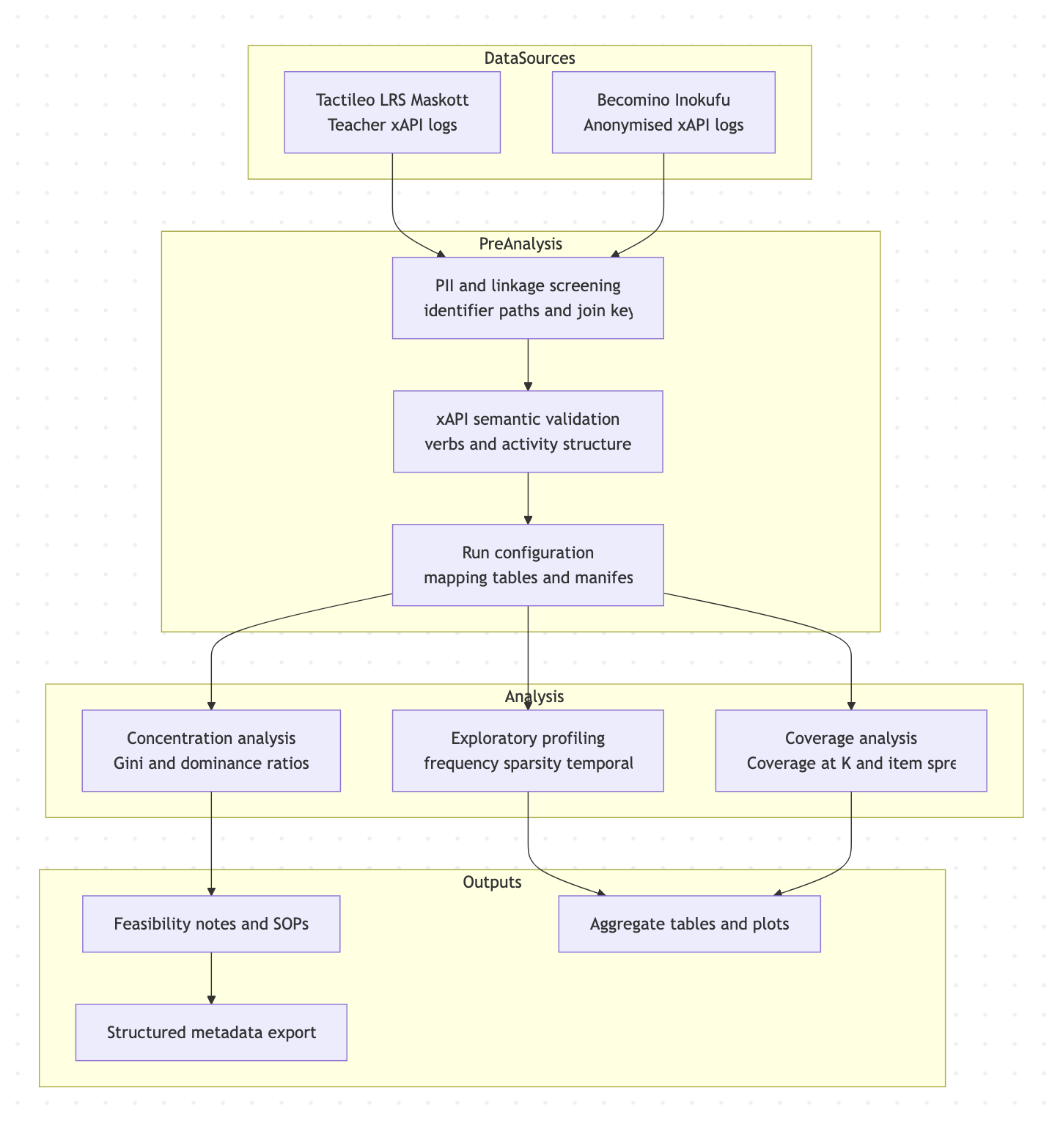
Figure 2. AffectLog Architecture and Analysis Pipeline

Use case feedback

CARiSMA Use Case
“up- and reskilling of employees within an organization” by IMC Scheer
The use of CARiSMA is agreed upon and defined in the testing plan for this use case, with progress toward local implementation testing.
Since CARiSMA is a solution to analyse systems and software during design time, it does not directly affect any use case during production time. Recently, it was agreed to analyse the use case’s architecture, “Up- and reskilling of employees within an organization” led by IMC Scheer. The use case does not depend on the CARiSMA solution. Application of CARiSMA supports the overall success of that use case, since before a use case goes to market, issues in the design with regard to security, privacy, and trustworthiness requirements can be identified and appropriately addressed. However, it does not guarantee the absence of security risks or issues with the EU’s AI Act compliance. Since CARiSMA is not involved after deployment of the use case and all building blocks, it is not part of the service chain(s) of the use case.
It is still planned to provide compliance support material generated by CARiSMA to participants who are interested and authorised to receive the results of an analysis report. This can be achieved via a data space solution component like the Prometheus-X connector. This would create a data exchange that does not have educational and skill data as its payload, but technical information describing specific data sharing scenarios of an educational and skill data space. Whether the orchestrator of the targeted use case will make use of the generated report in a way that requires a data exchange via a connector component is still under discussion and could look like the following Figure 3.
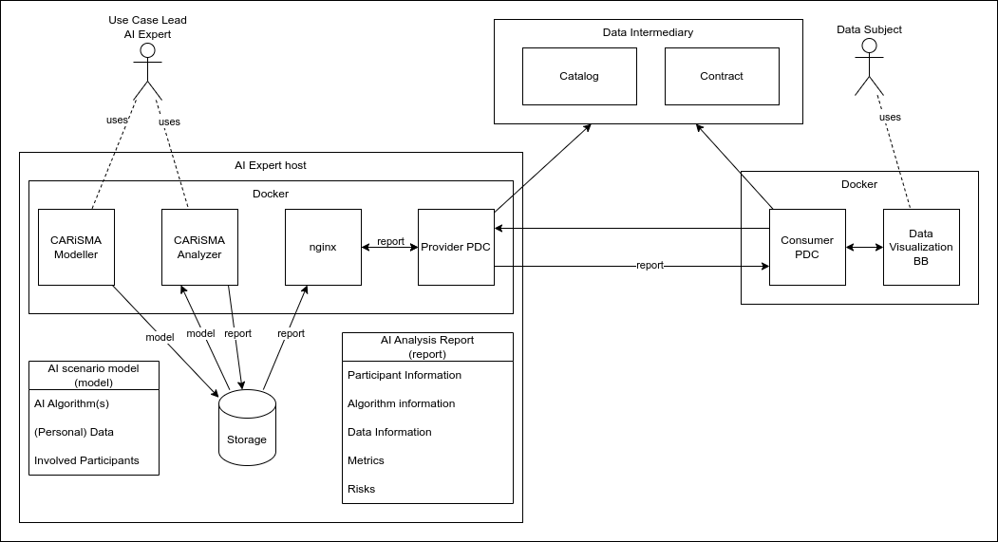
Figure 3. Architecture overview for sharing CARiSMA reports in Prometheus-X data space.

LOLA Use Case
NeoMaskott/Tactileo Use Case with LOLA
The current level of progress is at the stage where implementation has been tested locally, with plans to move towards the next stage, where integration via PDC will be working.
This use case was developed in collaboration with NeoMaskott, a French EdTech company and active partner of the EDGE-Skills project. It relied on the Trustworthy AI Assessment Building Block to design and execute a complete evaluation workflow for recommendation algorithms used in Tactileo, NeoMaskott’s digital learning platform with over five million users.
The LOLA platform provided a secure execution environment where the evaluation scenario was deployed. The Building Block served as the scenario provider and orchestrated the connection between three roles:
- the data provider (NeoMaskott, sharing real user interaction data in xAPI format),
- the algorithm provider (two recommender models, respectively provided by Collaborative Filtering and Content-based algorithms), and
- The scenario provider (LORIA, responsible for evaluation design and integration).
Through the LOLA architecture, all components were executed securely without direct access to personal data.
At the heart of every evaluation scenario, there are three elements: the data, the algorithm, and the evaluation metrics (Figure 4). In our project, these three parts are organized into two main steps. First, we prepare the data, and then we run the scenario.
Note: In this use case, the dataset is extracted from Maskott's operational Learning Record Store (LRS). This is standardized data (xAPI) mainly representing digital usage traces of the Learning Management System, Tactile. The dataset is loaded through the connector component (PDC).
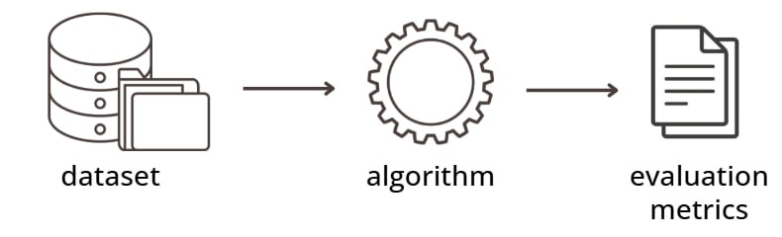
Figure 4. Scenario components
This use case will be presented in more detail in Section 4.

AffectLog Use Case
Maskott (Tactileo)
The current level of progress is at the stage where the use case has been contacted to agree on the usage of AffectLog BB in this use case.
- Dataset Description: MongoDB-sourced xAPI traces representing teacher activity, including session logs, quiz authoring events, and interaction histories.
- Methodological Pathway:
  - Raw data parsed using JSON schema inspectors to identify data hierarchy and field dependencies.
  - Raw xAPI objects were parsed using JSON schema inspection to identify event hierarchy, key paths, and field dependencies.
    - Identifier and linkage fields observed in the shared schema (e.g., TeacherId/username-style identifiers, session/log keys) were treated as potential personal data and assessed for pseudonymisation configuration in the feasibility notes.
  - Exploratory plots and summary tables were generated to characterise temporal density, event sparsity, and participation skew.
  - Concentration and coverage indicators were computed on the event–entity distributions: Gini Index = 0.68 and Coverage@10 = 72%.
    - Interpretation in this context: Gini = 0.68 indicates high inequality in activity contribution (a minority of teachers/events account for a large share of traces), which may bias learned similarities or co-occurrence statistics toward dominant users. Coverage@10 = 72% indicates that, across the evaluated top-10 lists (under the chosen analysis configuration), recommendations/visited items span ~72% of the unique item space observed, suggesting non-trivial diversity but with remaining concentration.
  - SOP-style outputs were produced to document field inventory, candidate pseudonymisation templates, and analysis configuration assumptions (dataset-only).
  - Output SOPs generated for pseudonymisation templates and compliance graphs.
- Key Findings: A marked long-tail with strong user dominance was observed; this is treated as a representational risk factor because models calibrated on such distributions can underperform for underrepresented teachers/content segments and may amplify dominant behavioural patterns when used for ranking or recommendation. The immediate mitigation implication at the dataset level is to evaluate splits/weighting strategies and to monitor exposure/coverage by strata (e.g., by activity frequency bands), rather than assuming the raw log distribution is representative.
- Outcome: The work performed supports the feasibility of running dataset-level analyses in a containerised environment, meaning execution of the profiling scripts within an isolated runtime (e.g., Docker) located on partner-controlled infrastructure, exporting only aggregate outputs. Any deeper integration (e.g., continuous monitoring or tighter coupling with an LRS/connector) was not performed in this reporting period and would require clarification of execution location, access patterns, and data egress constraints (“infrastructure alignment”).
Inokufu (Becomino)
The current level of progress is at the stage where the usage of AffectLog BB has been agreed upon and defined in the testing plan.
- Dataset Description: Anonymized JSON-based xAPI event logs from Becomino, containing user interactions categorized under verbs “accessed,” “opened,” and “searched.”
- Methodological Pathway:
  - Events were validated for structural consistency and normalised at the verb layer to ensure comparability across xAPI sources (see “xAPI normalization” description in the user guide).
  - Descriptive profiling was performed (verb frequency histograms, coarse sessionisation, and event co-occurrence summaries) to characterise usage patterns.
  - Findings were cross-checked against the previously shared risk report to confirm the absence of direct identifiers in the provided anonymised sample (dataset-only check).
- Key Findings: The dataset is consistent with anonymisation expectations for the provided sample; however, the available fields limit inferential richness for fairness/stratified analyses (e.g., limited contextual metadata about content, user roles, or learning objectives).
- Outcome: Recommended inclusion of non-identifying context metadata for future benchmarking, for example: content/category descriptors (topic/domain tags), coarse time buckets (e.g., week-of-year rather than timestamps), and item metadata necessary for exposure/coverage analysis—while avoiding direct identifiers.

CARISMA Updated User Guide

Basic information
Name of the Building Block: | Trustworthy AI Algorithms Assessment: CARiSMA
Link to the infrastructure service in the VisionsTrust catalog: | https://visionstrust.com/catalog/infrastructure/68395866dc12943a2215b1a7
Link to design document: | https://github.com/Prometheus-X-association/t-ai-carisma/tree/main/docs
Link to internal unit tests: | https://github.com/Prometheus-X-association/t-ai-carisma#unit-testing
Link to component level tests: | https://github.com/Prometheus-X-association/t-ai-carisma?tab=readme-ov-file#component-level-testing
Link to the demonstration video: | https://cloud.uni-koblenz.de/public.php/dav/files/kQy4GS3rR2MA4HJ/Correcting%20a%20model%20according%20to%20a%20failed%20report/correcting_model_wrt_to_report.m4v
License of the BB: | MIT License / EPL 1.0 License

Short summary of functionalities
The CARiSMA solution aims for a solution that allows for modelling an AI system and analyzing the system with regard to certain trustworthiness properties. These include the assessment of alignment of the modelled AI system with different security best practices, e.g. the mitigation measures defined by OWASP ML Security Top Ten, or the assessment of the system with regulatory compliance with European legislation in mind, e.g., the EU AI Act. The user (modeller / AI Expert) gets feedback about certain trust factors of the modelled AI system in the form of automatically generated reports. These reports can be used for improving the system’s design or to generate important artifacts for documentation purposes.

Demonstration of technical scenarios
Requirements
To create a Papyrus project, it is necessary to install Eclipse, Papyrus for Eclipse, and CARiSMA for Eclipse.
Creating a Model
To create a model, a new Papyrus project must be initiated. An existing project can also be used as a container for models. In this case, the Papyrus Model option should be selected in the dialog found under File → New → Papyrus Model. During this process, the user must select UML as the model type. Following this, a name for the Papyrus project needs to be entered. Additionally, a Diagram Name should be provided along with the selection of the desired diagram type. It is recommended to check the option for loading a UML model with basic primitive types as a template. This would facilitate the modeling process. Optionally, the UMLsec profile can be registered for the project by clicking on the ”Browse Registered Profiles” button. After selecting the UMLsec profile, the user should click OK and then Finish to open the new empty diagram.
Importing the UMLsec Profile After Model Creation
If the model is currently open, the .aird file of the project must be closed. The next step involves opening the /.uml/ file associated with the model in the Project Explorer. The <Model> element in the UML Model Editor should be selected. The user then needs to navigate to the menu item UML Editor → Package → Apply Profile. In the window that appears, the UMLsec profile should be chosen. Clicking Add will apply the profile, while OK confirms the selection. It is important for the user to remember to save the project. Upon re-opening the model in the .aird file, the UMLsec profile will be integrated. This will allow for the application of its stereotypes.
Applying Stereotypes After Applying the UMLsec Profile
If the model is open, the .aird file of the project must be closed. Afterward, the .uml file of the model must be opened in the Project Explorer. In the UML Model Editor, the element to which a stereotype is to be applied should be selected. Following this, the user needs to access the menu item UML Editor → Element → Apply Stereotype. In the appearing window, the UMLsec stereotype must be selected. Clicking Add will apply the stereotype, and OK confirms this action. It is crucial for the user to save the project afterward. If the model is reopened in the .aird file, the UMLsec stereotype will be added to the selected element.
Analyzing a Model with CARiSMA
To analyze a model with CARiSMA, it is essential that a model is created along with the application of the UMLsec profile, stereotypes, and tags. The process begins by clicking on File, then selecting New, followed by Other. From the options presented, the user should choose CARiSMA and then Analysis. At this point, the user is prompted to select a model to analyze. The .uml file of the created model should be chosen. Once this step is completed, the user should open the created .adf file and click the ”+” button. The user must then select a suitable check for the model created. The check should be run to obtain the results. If the check fails, a report can be created. Once the report is viewed, the user can interpret the results and modify the model according to the feedback from the check. The check process can then be repeated to verify the effectiveness of the corrections made.
Create a PNG or JPEG from a Model
To export a model as a PNG or JPEG file, the user should first open the model. Next, a right-click in the free drawing area will bring up a context menu. From this menu, the user must choose /File/ and then select the option to Save Image As File.

LOLA Platform Updated User Guide

Basic information
Name of the Building Block: | Trustworthy AI Algorithms Assessment: LOLA
Link to the infrastructure service in the VisionsTrust catalog: | https://visionstrust.com/catalog/infrastructure/68249500dc12943a22d83022
Link to design document: | https://github.com/Prometheus-X-association/t-ai-lola/blob/main/docs/design-document.md
Link to internal unit tests: | https://github.com/Prometheus-X-association/t-ai-lola/tree/main
Link to component level tests: | https://github.com/Prometheus-X-association/t-ai-lola/tree/main/stage2-test
Link to the demonstration video: | Technical demonstration: LOLA
License of the BB: | GNU General Public License v3.0 or later

Short summary of functionalities
LOLA takes the form of a platform for a community made up of educational data providers on the one hand, and AI providers on the other. This makes it possible to evaluate algorithms as closely as possible to the needs of the services envisaged, by combining the two contributions. As a result, LOLA can produce indicators related to the service being deployed.

Demonstration of technical scenarios
In this section, we describe the use case implemented in collaboration with the company NeoMaskott, which consists of evaluating two algorithms with the aim of implementing a recommendation system for teachers using the Tactileo platform.
Scenario Recommendations, Algorithms Assessment
To support the evaluation scenario, NeoMaskott provided two recommendation algorithms, each based on a different principle.
The first one is collaborative filtering (item-based), which uses the history of teacher-quiz interactions. The main idea is that if two resources are often used together by many teachers, they are considered similar. Based on this similarity, the system can recommend new quizzes to a teacher by looking at what other teachers have combined with the ones they already used
The second one is a content-based algorithm using TF-IDF, which does not look at how teachers used the resources, but instead at the information describing the resources. It processes textual properties such as the title, description, domain, skills, tags, or themes of a quiz, and then identifies other quizzes with similar descriptions.
In general, although the two algorithms (CF and TF-IDF) work in very different ways and rely on different types of information, their overall workflow follows the same pattern. In their original form, both algorithms were implemented as a single block (Figure 6):
- Data is loaded,
- The algorithm trains itself and makes predictions in one go,
- The final output is a list of recommended quizzes
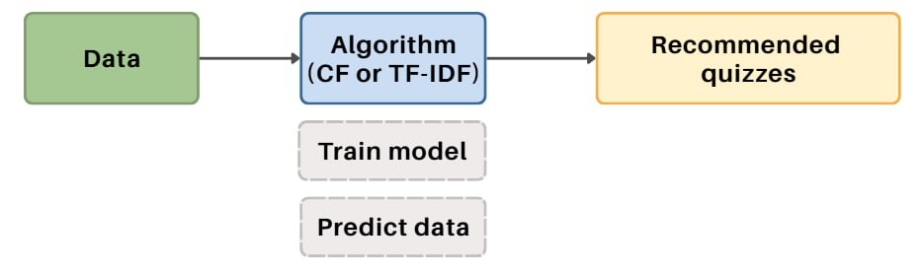
Figure 6. General original workflow
However, in our case, we need to change a little bit of logic. Instead of keeping everything inside one block, we separated the training part from the prediction part (Figure 7).
This was important for two reasons. First, it makes the process more reliable. If we run the same training data again, we will always get the same model, which makes experiments easier to repeat and compare. Second, it allows us to test the trained model many times on different sets of data, which is good to check how well the algorithm really works.

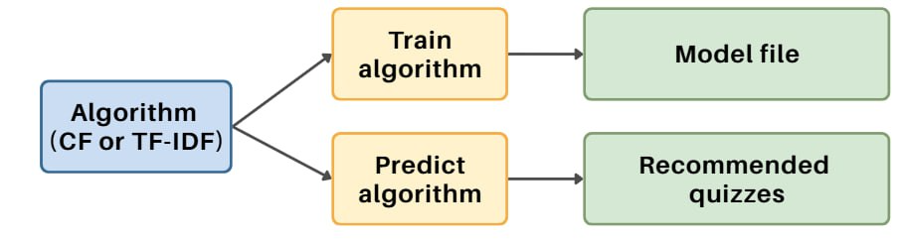
Figure 7. Split into training and prediction
When combined into the whole scenario, the workflow now looks as shown in Figure 8. Data is prepared, the model is trained, predictions are generated, and the results are compared with the expected output.
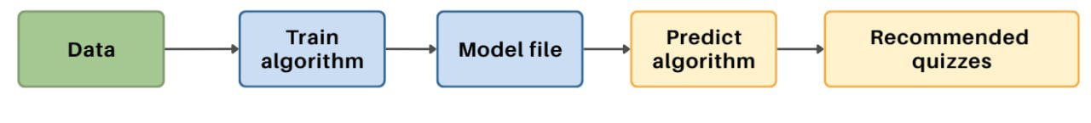
Figure 8. General scenario workflow
It is important to note that this workflow is generic. It does not show the internal differences of how each algorithm works. Our contribution was not to design the algorithms themselves, but to adapt them into this modular form so they could be integrated into the evaluation scenario.
Still, for a general understanding, Figure 9 illustrates the key distinction between the two approaches:
- Collaborative Filtering (CF) - uses teacher interactions (which quizzes teachers have used together),
- Content-based TF-IDF - uses quiz information (titles, descriptions, domains) to find similarities between resources.
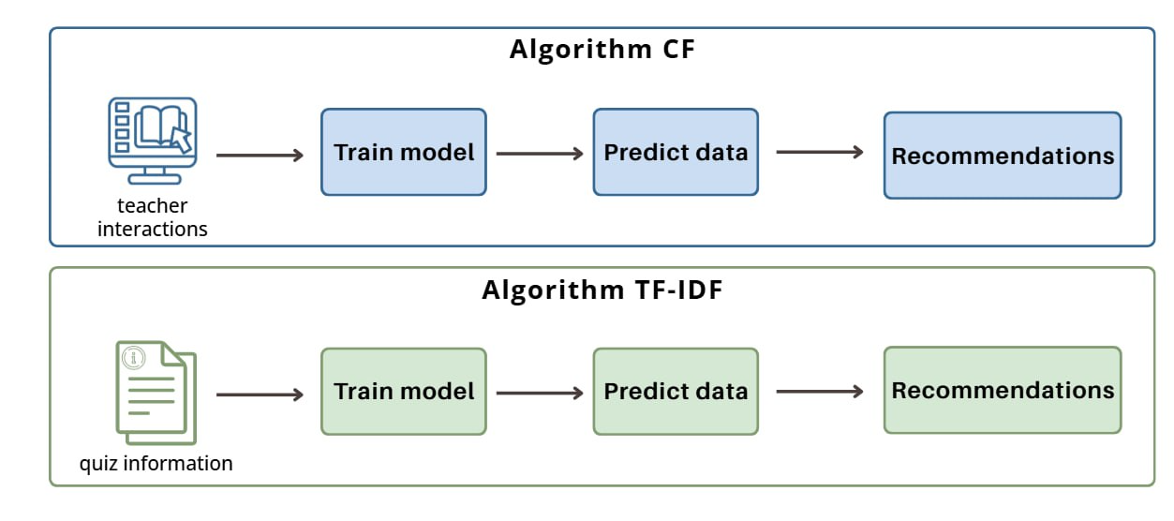
Figure 9. Input data difference between CF and TF-IDF
This way, both algorithms fit into the same scenario structure, while still keeping their individual logic for generating recommendations.
The general execution of a scenario always follows the same principle (Figure 4). First, the training data is requested from the LRS. A model is then trained on this data, predictions are generated on a test set, and these predictions are compared with the expected output. Finally, all results are aggregated into a single report.
In practice, this workflow is executed in parallel for several years of data (2018, 2019, …), as shown in Figure 10. Each train/test/expected triplet goes through the same pipeline, and the evaluation results are later combined.
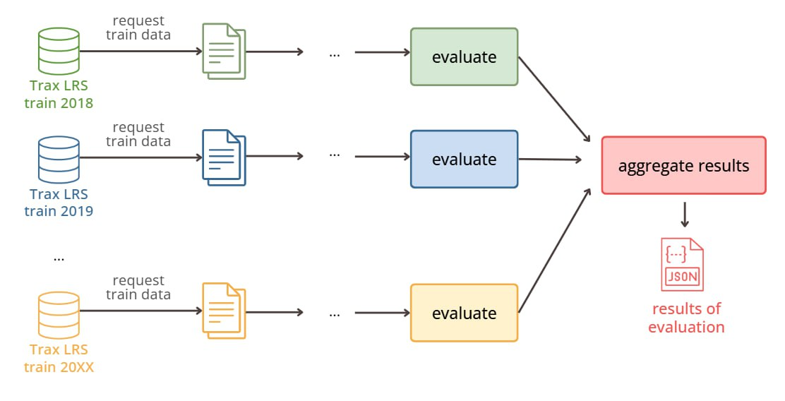
Figure 10. General workflow of a scenario in practice
Technically, the scenario is built on three layers (Figure 11). The Python scripts contain the actual logic for requesting data, training a model, predicting, and evaluating. These scripts are wrapped into Nextflow modules, which define how they are executed. Finally, the modules are orchestrated together in the main workflow, which ensures that all steps run in the right order.
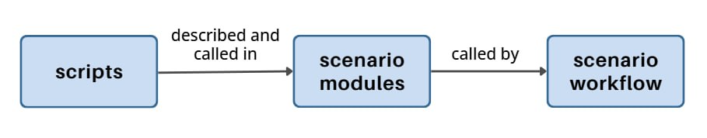
Figure 11. Layers of scenario
To illustrate the logic more concretely, let us look at a single example: training on 2018 data and testing on 2019.
Scenario 1 – Collaborative Filtering (CF)
For collaborative filtering (CF), the model relies on teacher-quiz interactions.
In our example, the system requests all teacher activities from 2018 and uses them to build a model of quiz similarities. In the next step, the model predicts which quizzes the 2019 teachers are most likely to use. These predictions are then compared with the actual quizzes used by teachers in 2019 (the expected output). The results of this comparison are stored for evaluation (Figure 12).
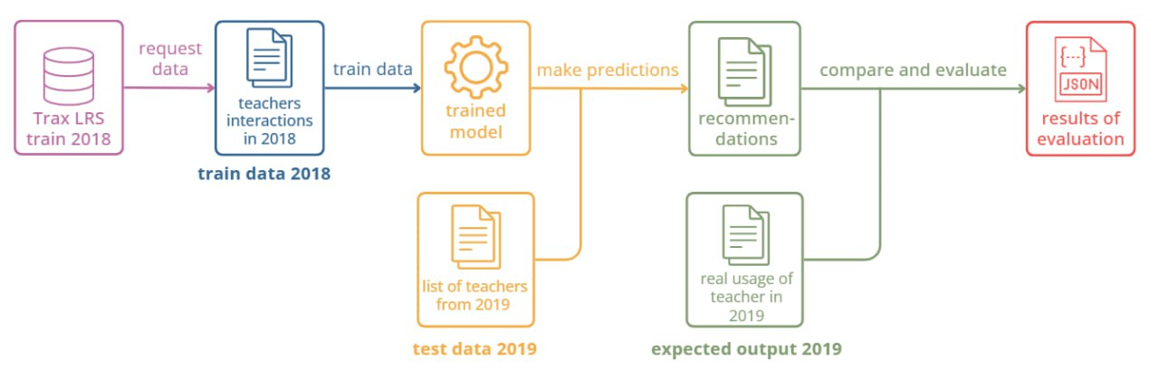
Figure 12. Workflow of the CF scenario
Scenario 2 – content-based
For TF-IDF, the training step is based not on teacher activity but on the metadata of the quizzes.
Here, the system requests quiz information from 2018 (titles, descriptions, tags, skills, domains, etc.) and uses it to build a similarity model between quizzes. During prediction, the model looks at the quizzes used by teachers in 2018 and suggests other quizzes with similar descriptions. As before, the predictions are compared with the real 2019 usage to evaluate accuracy (Figure 13).
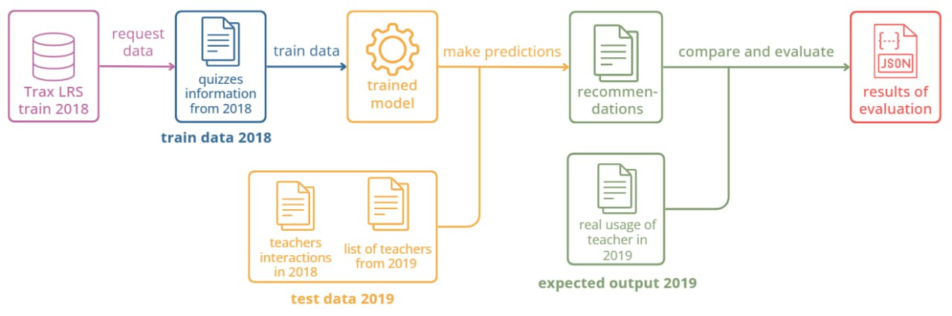
Figure 13. Workflow of the TF-IDF scenario
As shown in Figure 10, the outcome of a scenario execution is formed by aggregating the results of each evaluation. This result contains all the computed metrics defined in the scenario and, in this case, listed in section 2. Specifically, it is a JSON file intended to be sent to a visualization tool for analysis, as shown in Figure 14.
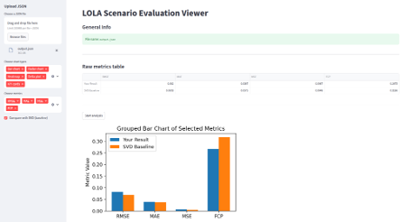
Figure 14. A visualisation tool

AFFECTLOG Updated User Guide

Basic information
Name of the Building Block: | AffectLog – Trustworthy AI Assessment (ALT-AI)
Link to the infrastructure service in the VisionsTrust catalog: | https://visionstrust.com/catalog/infrastructure/68401613dc12943a222a25e6
Link to design document: | https://github.com/Prometheus-X-association/t-ai-affectlog/blob/main/docs/design-document.md
Link to internal unit tests: | https://github.com/Prometheus-X-association/t-ai-affectlog/blob/main/docs/design-document.md#test-specification
Link to component level tests: | same “Test specification” subsection above
Link to the demonstration video: | https://drive.google.com/file/d/1-gpD3VHtJagLvXB0kk_CqE5qOSj9s6EB/view
License of the BB: | MIT License

Short summary of functionalities
- Multi-stage audit workflow for educational xAPI datasets
- Dynamic schema parser supporting nested JSON and CSV exports
- Fairness metric suite: Gini, Coverage@K, nDCG, Representation Index
- Pseudonymisation benchmarking with SHA-256 and reversible salt variants
- Automated Annex IV metadata exporter (JSON-LD)

Demonstration of technical scenarios
Scenario A – Tactileo Teacher Logs
Executed within a secure sandbox; xAPI events loaded, PII redacted, skew plotted, and bias metrics applied. SOPs exported for reproducibility.
Scenario B – Becomino Interaction Logs
Static audit of anonymized logs using schema validation, verb harmonization, and event correlation graphs. Generated compliance-ready metadata JSON.
Technical Architecture and Analysis Workflow
The diagram below depicts AffectLog’s integrated architecture for Maskott and Inokufu use cases. It visualizes each analytical phase from ingestion to compliance graph generation.
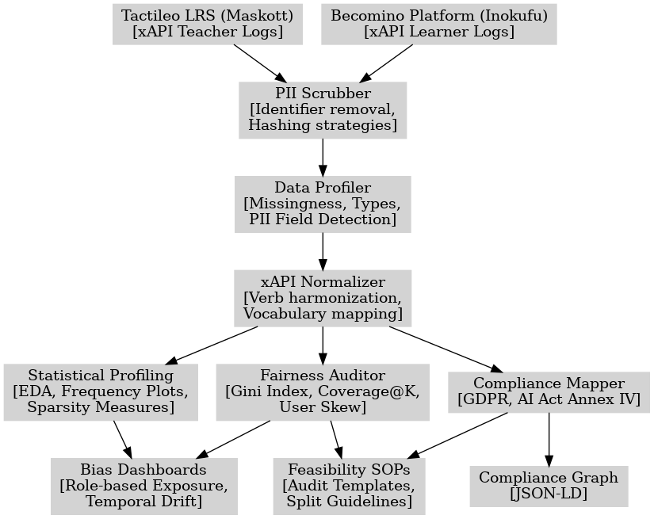
Figure 5. AffectLog Architecture and Analysis Pipeline
Figure 5 illustrates the multi-stage analytical workflow designed and executed within the AffectLog Building Block. Two heterogeneous xAPI sources — Tactileo (Maskott) and Becomino (Inokufu) — feed into a unified audit pipeline. The process begins with a PII Scrubber (responsible for field-level hashing and identifier removal), followed by a Data Profiler that quantifies data completeness, variable types, and potentially sensitive attributes. The xAPI Normalizer harmonizes verbs and vocabulary across datasets using a configurable mapping table aligned with xAPI verb IRIs and partner-provided verb lists; mappings are user-controlled (reviewable/editable) and can be versioned per dataset so that analyses remain reproducible and do not silently alter semantics. From this stage, three analytical modules operate in parallel:
- Statistical Profiling, producing EDA plots, frequency distributions, and sparsity measures;
- Fairness Auditor, calculating interpretability metrics such as Gini Index, Coverage@K, and User Skew;
- Compliance Mapper, aligning dataset fields with relevant GDPR and AI Act (Annex IV) requirements.
Final outputs include Bias Dashboards, Feasibility SOPs, and Compliance Graphs in JSON-LD format, ensuring full audit traceability without exposing raw personal data.
Workflow Description
- Data Sources: Teacher logs from Maskott’s Tactileo LRS and learner logs from Inokufu’s Becomino platform serve as heterogeneous xAPI sources.
- PII Scrubbing: Performs deterministic hashing and field-level obfuscation using SHA-256 and optional random salt for non-critical identifiers.
- Data Profiling: Computes completeness ratios, entropy scores, and identifies residual identifiers through recursive type analysis.
- xAPI Normalization: Aligns verbs across datasets and standardizes activity structures via canonical mapping.
- Statistical Profiling: Applies EDA routines to quantify sparsity and temporal drift; visual outputs include histograms and density maps.
- Fairness Auditing: Implements the Gini Index for concentration inequality and Coverage@K to assess representational balance across entities.
- Compliance Mapping: Uses RDF/JSON-LD export templates to align detected data flows with GDPR and AI Act articles.
- Outputs: Consolidated into Bias Dashboards, Feasibility SOPs, and Compliance Graphs, all auditable and shareable without exposing raw content.

Summary

Summary of the implemented service
For CARiSMA, the first phase of the project was used to define the architecture of the extensions to be developed and how the solution could be integrated into the overall data space architecture. A detailed testing plan was created to integrate existing, but also new, automated Unit tests of CARiSMA into the build and integration process of CARiSMA. The software build process was turned from a manual process into an automated process that eases installation and deployment. CARiSMA was designed as a desktop application. A setup was developed to run CARiSMA on a remote server that a client's desktop can connect to. To this end, the software was containerized, and two different setups are now available and documented. This aligns with the overall requirements for PTX data space building blocks. Finally, an initial AI scenario model was developed to evaluate existing UMLsec checks wrt to applicability in AI contexts to detect AI-specific threats as described by the OWASP ML Security Top Ten project.
For LOLA, the first phase involved developing the platform's overall architecture and testing it on a simple use case using public data and a fictitious application. The second phase consisted of demonstrating a proof of concept with real data from the use case proposed by our partner NeoMaskott/CabriLog, on an existing service within their own LMS.
This initial experience taught us the complexity of maintaining the security and confidentiality of personal data during the overall assessment process.
Furthermore, in collaboration with our Use Case Leader, we also demonstrated the importance of fundamental studies to gather best practices in metrics for conducting a neutral and independent audit.
During this period, AffectLog contributed a lightweight dataset-profiling workflow applied to two exploratory use cases (Maskott and Inokufu). The implemented service focused on three steps already completed: (i) PII and schema inspection of xAPI logs, (ii) basic statistical profiling (event types, sparsity, temporal patterns), and (iii) initial fairness indicators (activity skew, simple concentration metrics). For Maskott, analysis covered the teacher-only dataset extracted from Tactileo, including identifier structures, correspondence tables, and verb distributions. For Inokufu, work was limited to the anonymised Becomino dataset previously shared, with descriptive profiles of “accessed/opened/searched” traces. The outputs consisted of short feasibility notes and SOPs; no model training or integration steps were performed.

Planned Improvements
CARiSMA: The initial AI scenario model is evaluated and aligned with a real scenario as defined by the use case described in Section 2.2 (use case feedback). Further language constructs are defined to cover a broader range of OWASP ML Security Top Ten’s catalog. The described approach for supporting the EU AI Act’s compliance requirements will be further developed and validated. The integration into the data space or its use cases, respectively, will be extended. On the CARiSMA side, the PDC is ready to provide data (in an experimental setup); the consuming parties need to be involved as part of the evaluation within a use case. The CARiSMA software itself is currently updated to recover and maintain compatibility with the latest version of the UML modeling tool Papyrus, which received breaking changes in 2025. Finally, it’s planned to further validate and extend existing work on a data sovereignty analysis approach implemented in CARiSMA.
LOLA: At this stage, a version of the platform is being implemented within LORIA's internal structure. This infrastructure, called the High Security Laboratory (LHS) (https://lhs.loria.fr/), hosts all research developments requiring specific data security. This infrastructure offers both the ability to archive datasets containing learners' personal data and the processing capacity to test algorithms on a local cluster.
According to our roadmap, the next step will be to develop an open source version 2.0 of LOLA deployable in a public cloud offering standard services like those provided by project partners such as Outscale and Orange. By extension, the new version could also be deployed in a company's private infrastructure for internal evaluation of AI algorithms.
AffectLog: Planned work includes stabilising the profiling scripts into self-contained modules suitable for local execution, refining concentration/fairness measures to align with consortium evaluation practices, and preparing optional metadata-only exports intended for interoperability with other Trustworthy AI Building Block services in this deliverable (i.e., LOLA/CARiSMA) and/or dataspace tooling that consumes structured documentation pending feasibility and relevance. Candidate metadata formats include lightweight dataset documentation artifacts (e.g., data dictionary + profiling summary, and optional structured descriptors, and machine-readable graph exports already used in the current workflow (JSON-LD).

Extension possibilities
CARISMA: CARiSMA is characterized by its plugin architecture. Extensibility was a general guideline during its architectural design. Additional plugins can add functionalities that are not planned yet. Not only can additional UML profiles be developed and integrated into CARiSMA, based on these, but new checks can also be developed and implemented. It is worth considering covering additional topics in the context of IT security and privacy, or in the context of regulatory compliance checking or quantitative risk assessments. It is even possible to add additional modeling languages, like SysML checks that process BPMN diagrams.
LOLA: Regardless of the use case for a LOLA platform (deployment on a data provider's private infrastructure, as a service operated by an auditing company, or as an open public platform), potential extensions depend on the ability of stakeholders to enrich the ecosystem with open-source, shared, and reliable quality assessment scenarios.
AffectLog: Potential extensions primarily depend on enabling stakeholders (data providers, auditors, and infrastructure operators) to contribute reusable, open, and versioned “assessment recipes” for dataset-level profiling (schema/PII checks, xAPI verb harmonisation, EDA, and concentration indicators) that can be executed locally on partner-controlled infrastructure. A second extension axis is interoperability, i.e., publishing metadata-only outputs (e.g., profiling summaries, evidence indices, optional JSON-LD descriptors) in formats that can be consumed by other BB services or dataspace tooling, without exporting raw data. Finally, extensions require agreement on governance and execution constraints (where code runs, access permissions, output granularity, retention) to ensure that outputs remain audit-ready while staying within the dataset-only scope demonstrated in RP1.

Annex A – Design document of the Building Block

https://doi.org/10.5381/jot.2025.24.2.a9

